**PURBANCHAL UNIVERSITY**



**DEPARTMENT OF COMPUTER ENGINEERING**

**KHWOPA ENGINEERING COLLEGE  
LIBALI-8, BHAKTAPUR**

**A PROJECT POROPSAL**

**ON**

**ONLINE MOVIE TICKET BOOKING SYSTEM**

Project work submitted in partial fulfillment of requirements for award of the degree of

Bachelor of Engineering in Computer Engineering (Fourth Semester)

**SUBMITTED BY**

Sumina Awa (770345)

**Under the supervision of**

Er. Milan Chikanabanjar

12 June 2023

**DEPARTMENT OF COMPUTER ENGINEERING KHWOPA ENGINEERING COLLEGE LIBALI-8, BHAKTAPUR**

## CERTIFICATE OF APPROVAL

This is to certify that the project entitled “**Online Movie Ticket Booking System**” submitted by Ms. Sumina Awa as partial fulfillment of the requirements for the award of the Degree of Bachelor of Engineering in Computer Engineering of Purbanchal University has been examined by us and may be placed before the examination board for their consideration.

**Panel of Examiners:**

**Name Signature Date**

**Head of Department**

Er. Bikash Chawal ........................

**Project Supervisor**

Er. Milan Chikanbanjar ……………….

## ACKNOWLEDGEMENT

First and foremost, I would like to express my heartfelt gratitude to **Er. Milan Chikanbanjar** of **Department of Computer Engineering, Khwopa Engineering College, Bhaktapur** for providing us a golden opportunity to work on this project ‘Online Movie Ticket Booking System’ and also, I am grateful for his suggestion and supporting during the development, implementation and presentation work.

And a big thanks to those who have directly or indirectly guided us during the completion of our project.

## ABSTRACT

Online Movie ticket booking has been more practiced around world. This report details the development of the online ticket booking system that is written in the HTML, CSS, PHP and MySQL. This application can be written as well in other various languages. The aim of this webpage is to provide easy online booking system to the user. Moreover, the report specifies how the goal of the project can be achieved. Thus, I have tried to make this project like a real one and user friendly too. Finally, the report summarizes the overall achievements of the application development and indicates other possible extensions.

The Online Movie Ticket Booking System which is named cinephile can be used easily through register/login in the website that includes checking out the remaining seat, current movie shows with their time, payment through cards, adding the movies in the website, editing and deleting the details of movie as well as the users according to wish.

Keywords: *online movie ticket booking, seat reservation*

**LIST OF ABBREVATION**

HTML Hyper Text MarkUp Language

CSS Cascading Style Sheets

PHP Hypertext Preprocessor

MySQL My Structures Query Language

**LIST OF FIGURES**

|  |  |  |
| --- | --- | --- |
| **Figure No.** | **Figure Name** | **Page** |
| Fig 4.1 | Block diagram | 4 |
| Fig 4.2 | ER Diagram | 4 |
| Fig 4.3 | Flowchart | 5 |
| Fig 4.5 | Data Dictionary | 6 |
| Fig 5.1.1 | Index page | 8 |
| Fig 5.1.2 | Ticket Rate page | 9 |
| Fig 5.1.3 | Contact page | 9 |
| Fig 5.1.4 | Gallery page | 10 |
| Fig 5.1.5 | Login page | 10 |
| Fig 5.1.6  Fig 5.1.7  Fig 5.1.8  Fig 5.1.9  Fig 5.1.10 | Register page  Ticket Book page  Payment page  Admin panel page  Admin Adding Movie page | 10  11  12  12  13 |

**Table of Contents**

|  |  |  |
| --- | --- | --- |
| **Chapter** | **Title** | **Page** |
| 1 | Introduction  1.1 Background  1.2 Motivation  1.3 Statement of Problems  1.4 Objectives  1.5 Application  1.6 Scope & Limitation | 1-2  1  1  1-2  2  2  2 |
|  |  |  |
| 2 | Literature Review | 3 |
|  |  |  |
| 3 | Methodology  4.1 Block Diagram  4.2 ER Diagram  4.3 Flowchart  4.4 Tools & Platform  4.5 Data Dictionary | 4-7  4  4  5  6  6-7 |
|  |  |  |
| 4 | Result and Discussion  5.1 Screenshots  5.2 Conclusion | 8-13  8-13  13 |
|  |
|  | Reference | 14 |

**CHAPTER 1**

# INTRODUCTION

## 1.1 Background

A movie also called a film, motion picture, moving picture, picture, photoplay or (slang) flick is a work of visual art that simulates experiences and otherwise communicates ideas, stories, perceptions, feelings, beauty, or atmosphere through the use of moving images. The word "cinema", short for cinematography, is often used to refer to filmmaking and the film industry, and to the art form that is the result of it.. The film making actually begunin the 19th century.

Most movies are made so they can be watched at home or on a movie screen at movie theaters. Movies are shown in movie theaters a few weeks or months after or before the movie is released. Movies can be marketed using media. Movies are shown on pay television or cable television, or are sold or rented on DVD disks or videocassette tapes, so that people can watch the movies at home. Movies can also be downloaded or streamed. Some movies are shown on television broadcasting stations.[1]

An online movie ticket booking system facilitates the purchasing of movie tickets to its customers. E-ticketing systems allow customers to browse through movies currently playing and book seats, anywhere and anytime.

## 1.2 Motivation

As being introduced with technology and knowing its importance the main motivation behind developing this project is because it provides improved customer experience, streamlined online movie ticket booking operations, easy access to new movies, increased transaction amounts, more customer control over orders and easier processes.

## 1.3 Statement of Problems

As industries are fast expanding, people are seeking for more ways to perform every works online and use the technology for all the activities. The manual method of going to movie hall and watching the movie. At time it is not possible to have the theatre experience as seats gets full and also we need to go to the theatre to know the new movies being played there. This method of manual booking is obsolete and even waste time often. So, there is need for a different approach of booking seat reserving and knowing the movie showed. For this online movie ticket booking system (cinephile has been developed To modify the film with time a system administrator who will have the rights to enter the film description.

## 1.4 Objectives

The main objective of my project is to learn how to implement theoretical knowledge into practical life and learn more things in details.

## 1.5 Application

Using online movie ticket booking system users book movie ticket through PC, tablets and smartphones. They can access ticket booking, payment availability of seats, watch own details. This dynamic website access movie adding and deleting facility.

## 1.6 Scope & Limitation

* It will show the available movies and the timing of the movies.
* The user can easily watch the remaining available seat visually and book according to convenience.
* It has efficient log in system.
* Movies can be added delete and updated according to system administrator wish.
* Easy viewing customer details and ticket purchased transaction.
* Due to time constraints, the software that is developed covers only the aspect of payment facilities.

**CHAPTER 2**

# LITERATURE REVIEW

I have been studying different online website to understand their process of maintaining their system and looking at variety of YouTube videos to learn the process of maintaining database and level of efficiency they have in their system and drawbacks of their existing systems. After visiting many such sites, I thought of developing a system which would help in easy online ticket booking system.

**CHAPTER 3**

# METHODOLOGY

## 4.1 Block Diagram

The block diagram of my project is shown below:

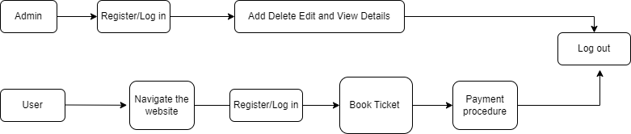

Fig 4.1 Block Diagram

## 4.2 ER diagram

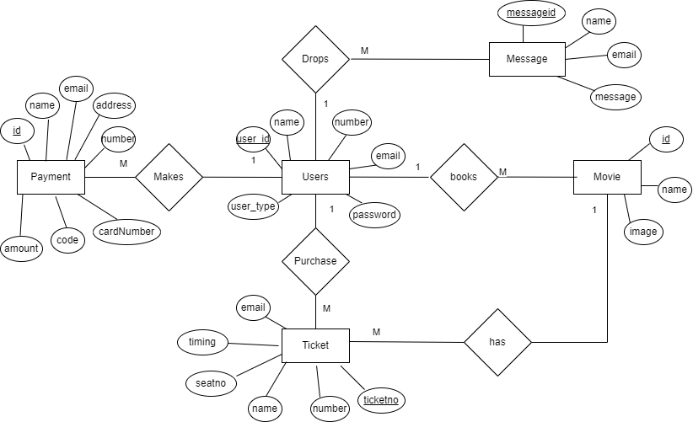

Fig 4.2 ER Diagram

## 4.3 Flow Chart

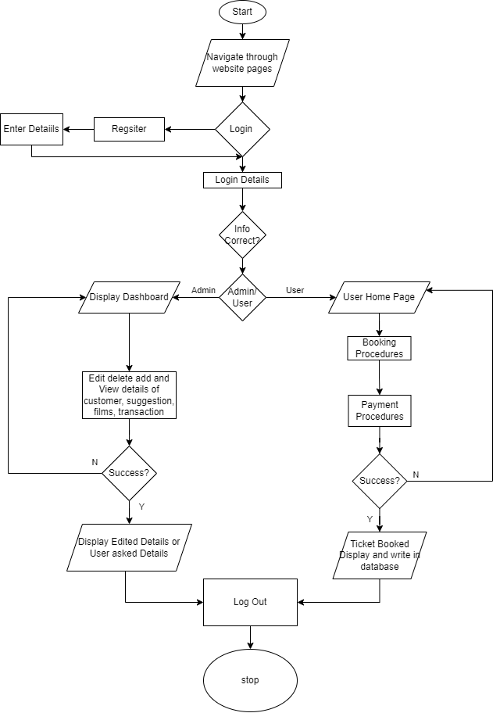

Fig 4.3 Flow Chart

## 4.4 Tools and Platform

Software

* Software: XAMPP, MySQL

Platforms

* Windows

## 4.5 Data Dictionary

### tbl_user

|  |  |  |
| --- | --- | --- |
| **Field Name** | **Data types** | **Size** |
| userid | int | 20 |
| name | varchar | 25 |
| email | varchar | 50 |
| user_type | varchar | 30 |
| password | varchar | 255 |

### 2.tbl_ticket

|  |  |  |
| --- | --- | --- |
| **Field Name** | **Data types** | **Size** |
| ticketno | int | 11 |
| Seatno | Varchar | 20 |
| name | varchar | 255 |
| number | Int | 15 |
| movie | varchar | 40 |
| timing | varchar | 50 |
| email | varchar | 50 |

### 3.tbl_payment

|  |  |  |
| --- | --- | --- |
| **Field Name** | **Data types** | **Size** |
| Id | int | 11 |
| Name | Varchar | 20 |
| Email | varchar | 20 |
| Address | Varchar | 40 |
| number | Int | 15 |
| cardName | varchar | 40 |
| cardNumber | Int | 20 |
| expM | Date |  |
| expYear | Int | 5 |
| Code | Int | 10 |
| Amount | Int | 255 |

### 4.tbl_movie

|  |  |  |
| --- | --- | --- |
| **Field Name** | **Data types** | **Size** |
| id | int | 11 |
| name | varchar | 255 |
| image | varchar | 100 |

### 2.tbl_contact

|  |  |  |
| --- | --- | --- |
| **Field Name** | **Data types** | **Size** |
| messageid | int | 11 |
| name | varchar | 255 |
| email | varchar | 20 |
| message | varchar | 200 |

**CHAPTER 4**

# RESULTS AND DISCUSSION

I have created online ticket booking system - cinephile where customers can book ticket easily. Customers can see available movies, available seats and admin can perform CRUD operations. The UI is also very easy to use.

## 5.1 Screenshots

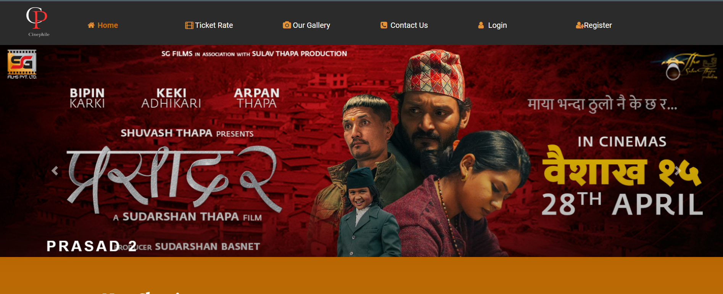

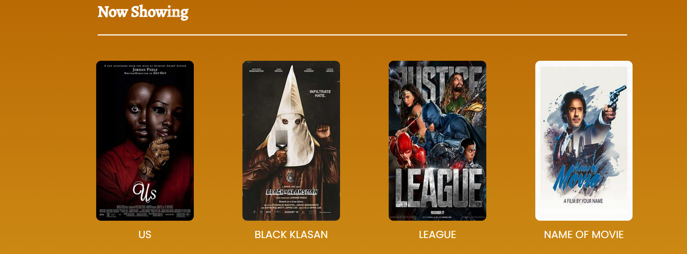

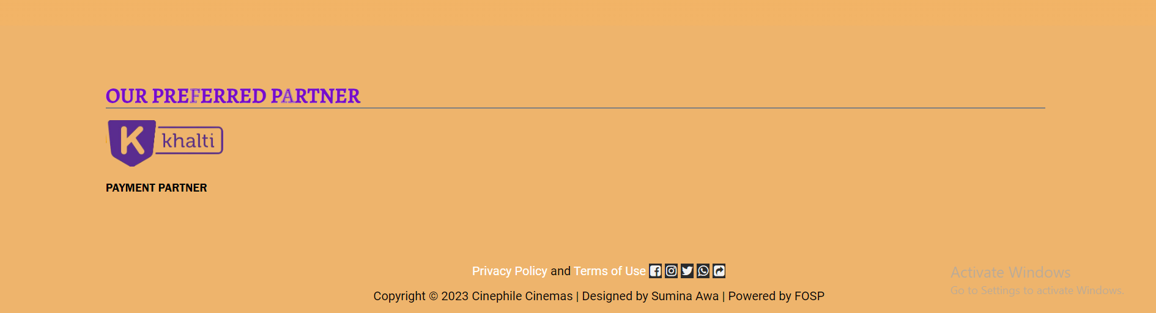

Fig 5.1.1 Index page

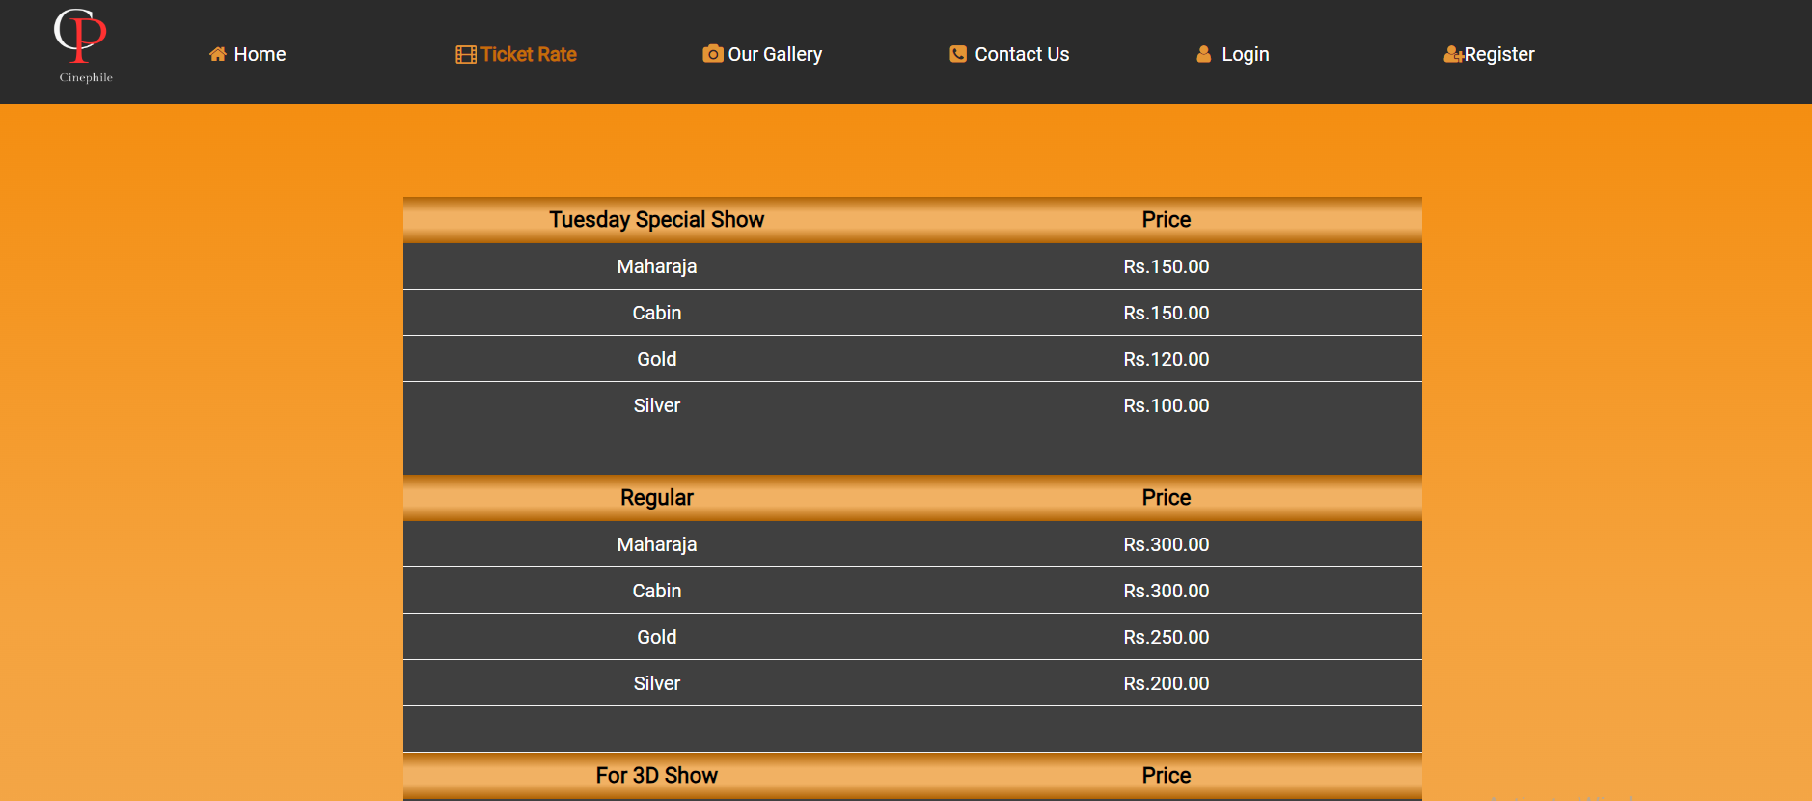

Fig 5.1.2 Ticket Rate page

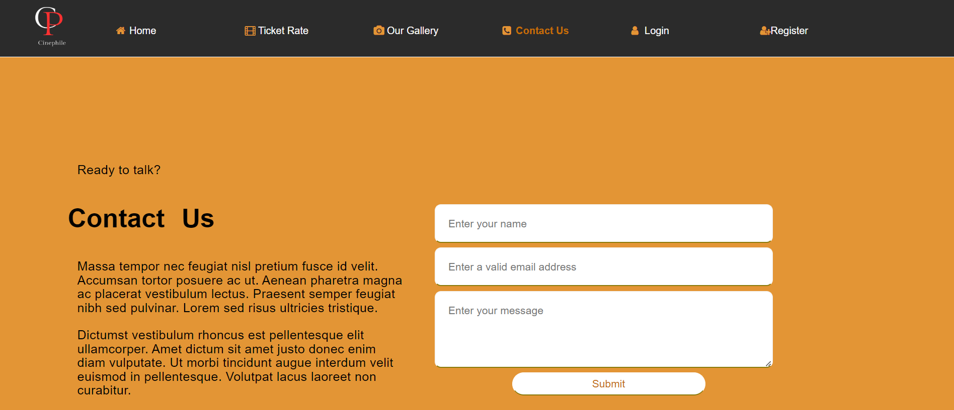

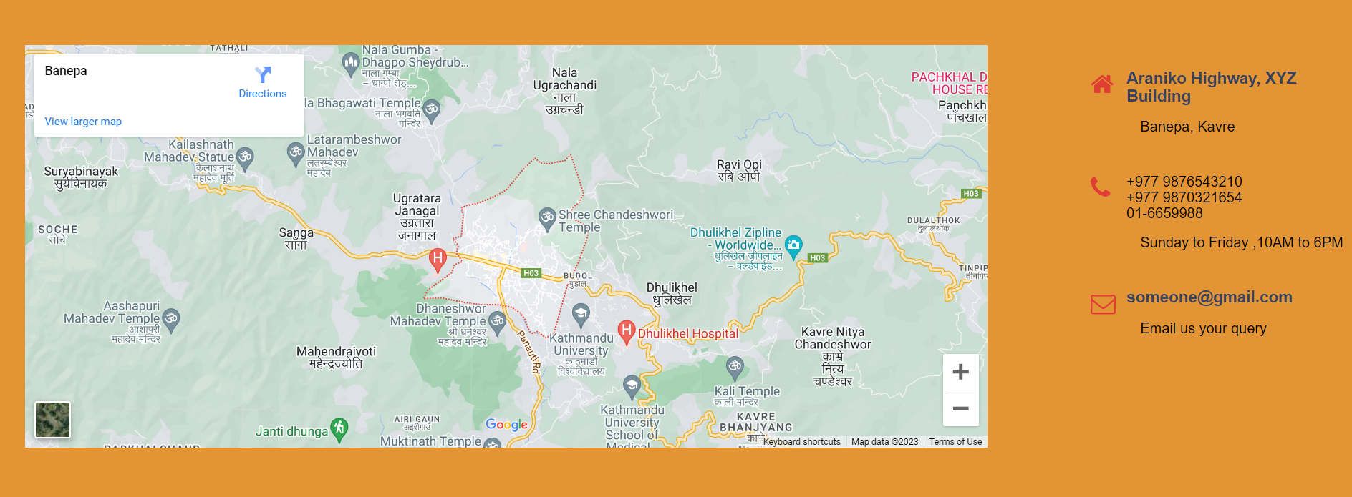

Fig 5.1.3Contact page

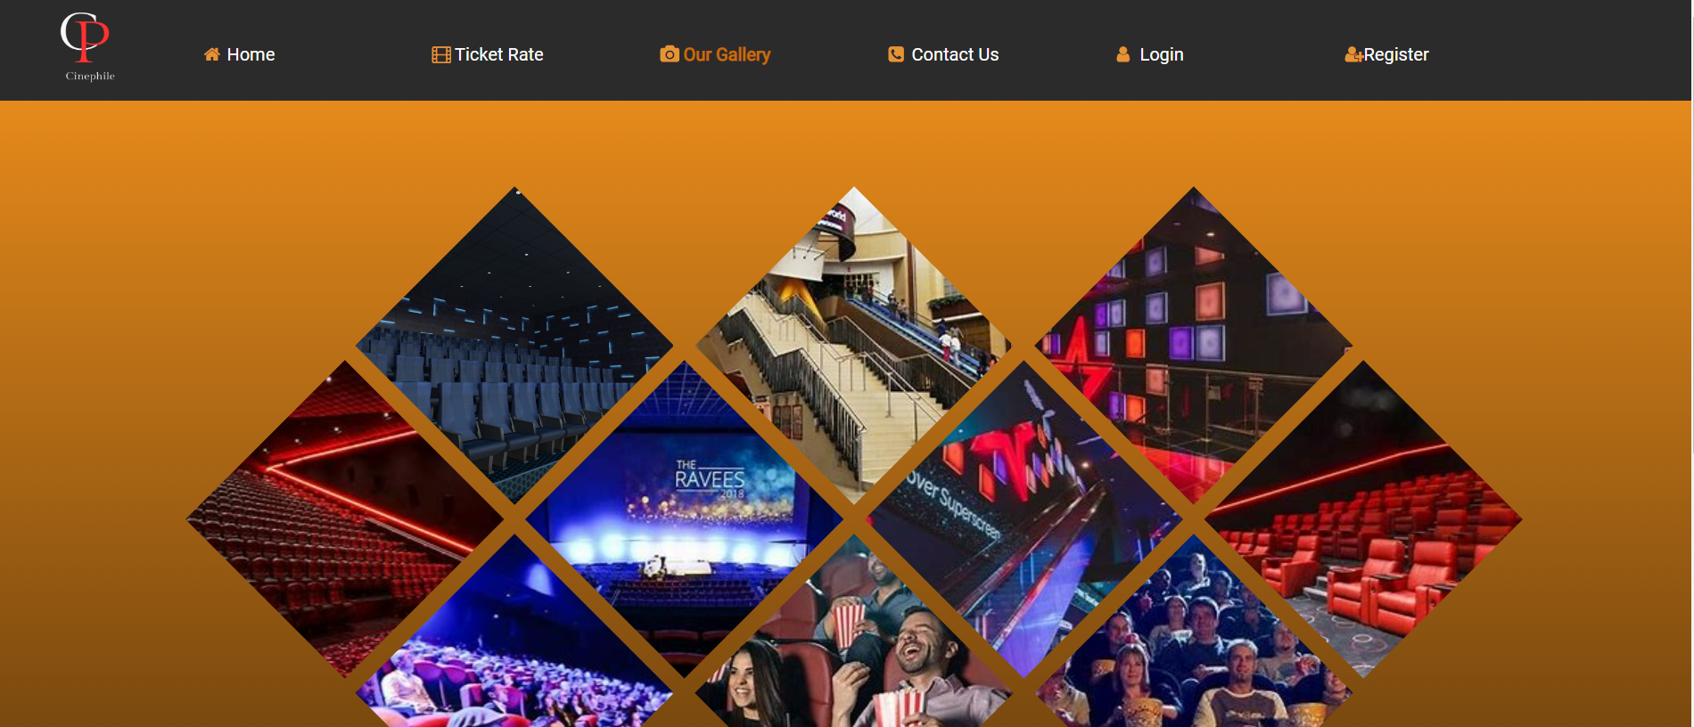

Fig 5.1.4 Gallery page

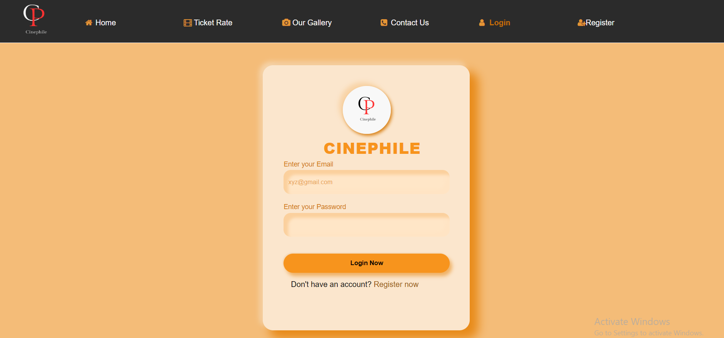

Fig 5.1.5 Login page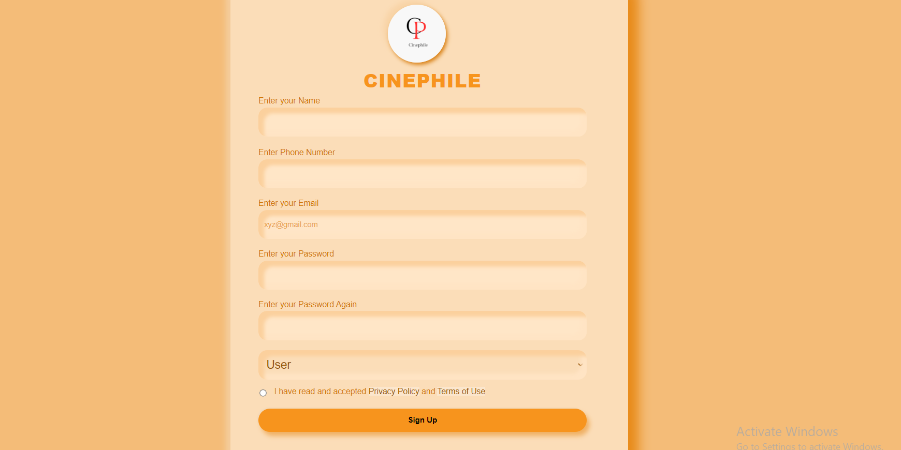

Fig 5.1.6 Register page

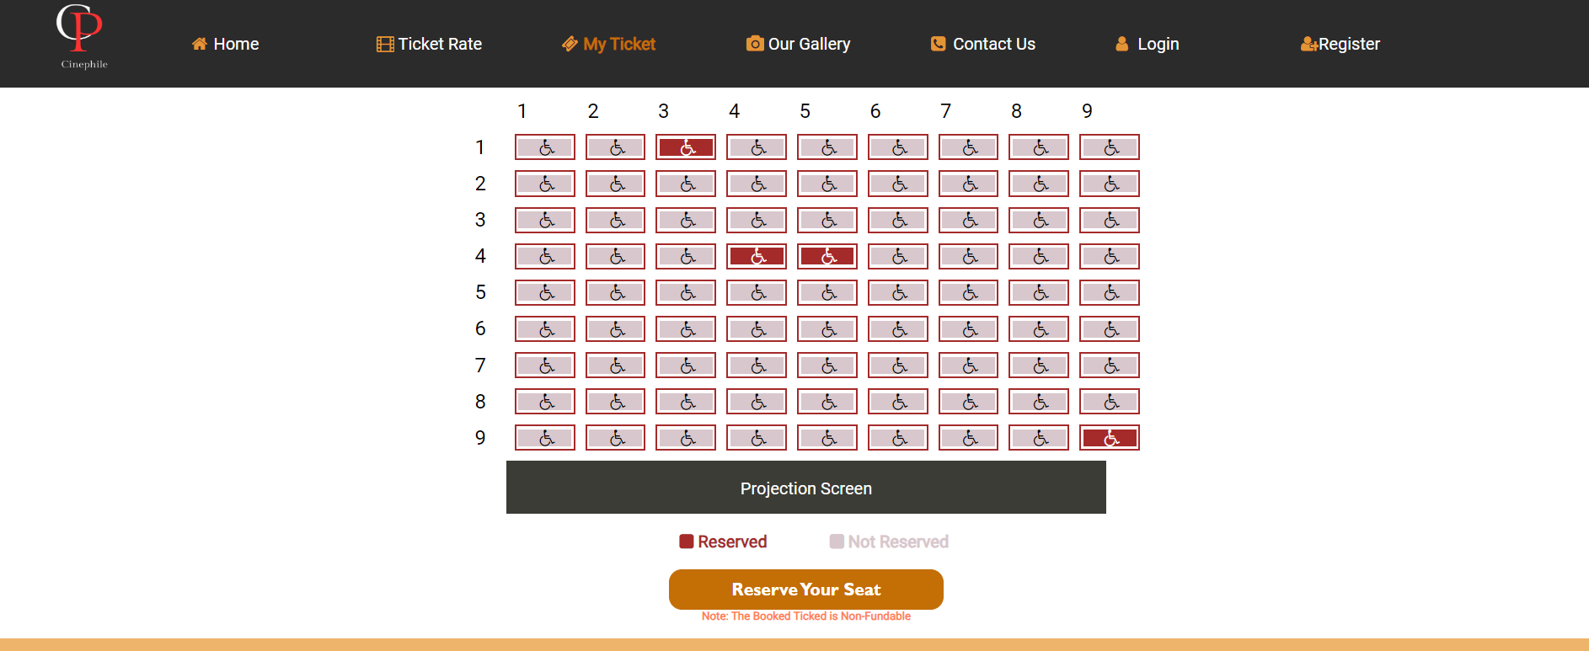

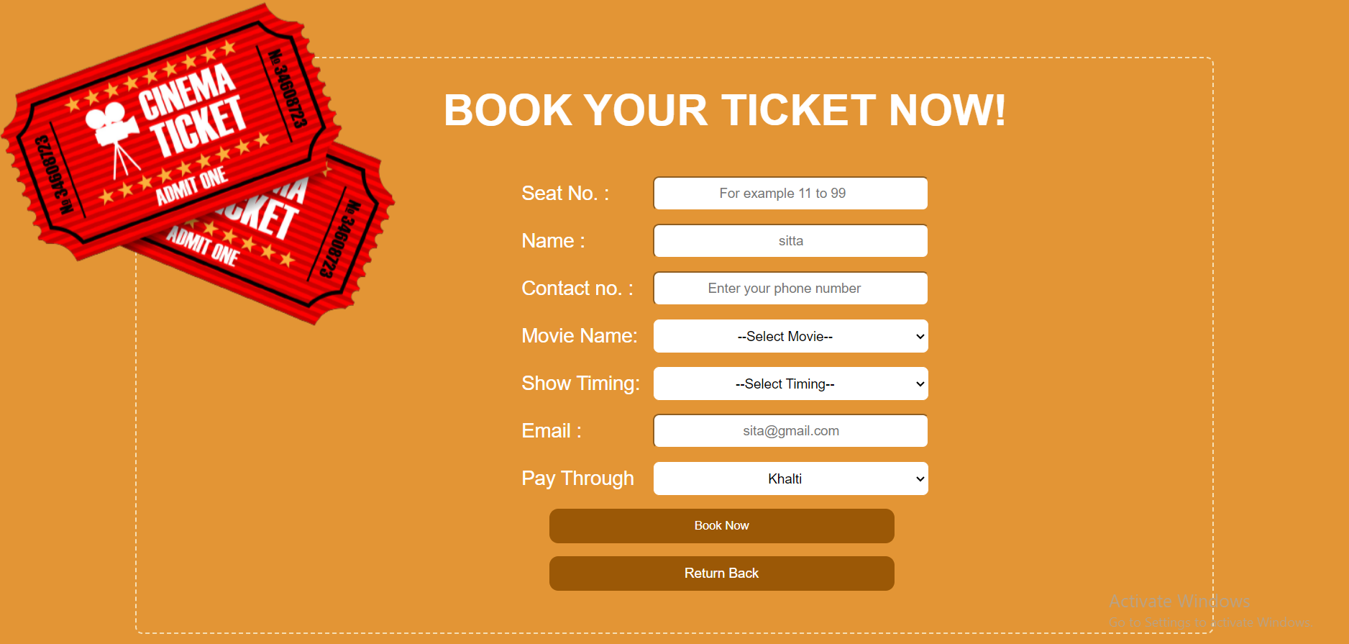

Fig 5.1.7 Ticket Book page

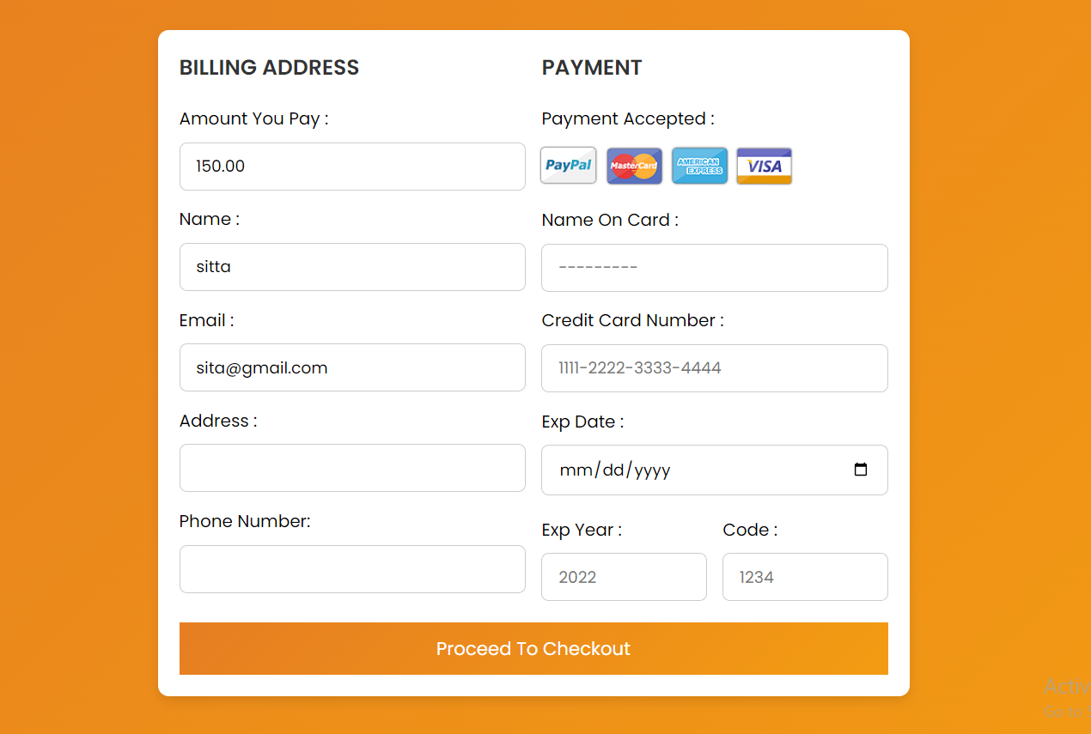

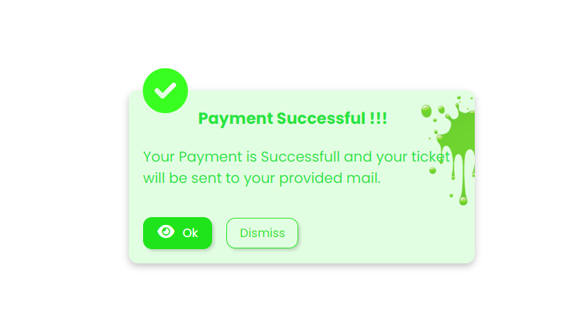

Fig 5.1.8 Payment page

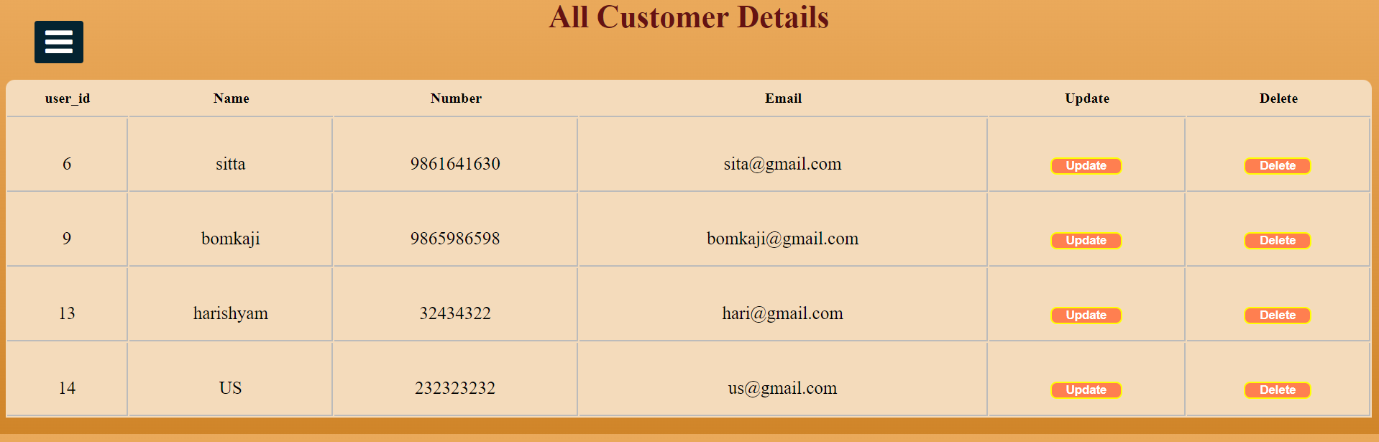

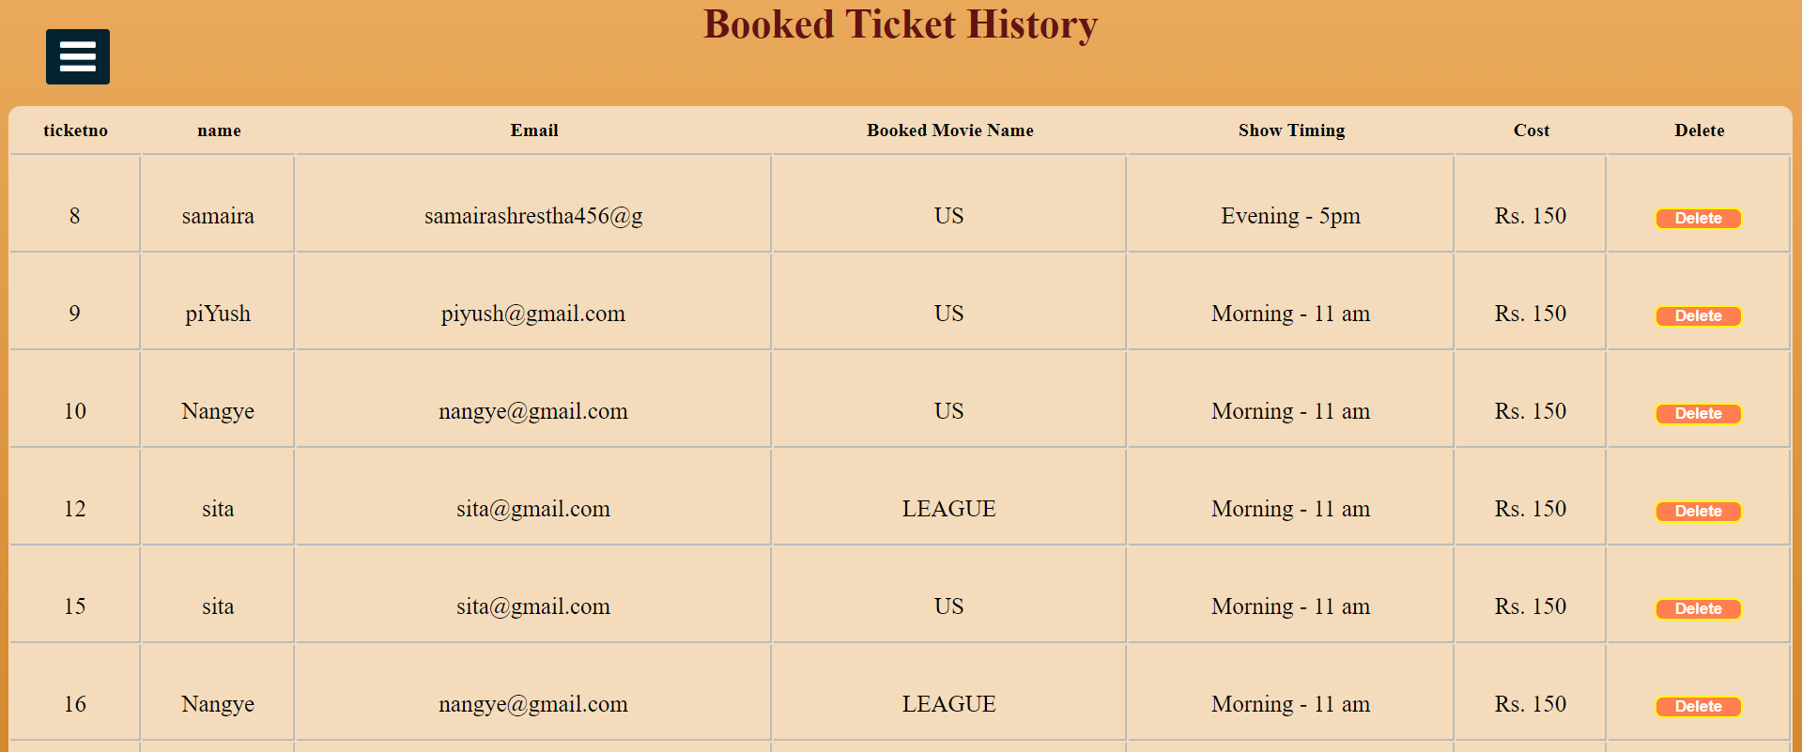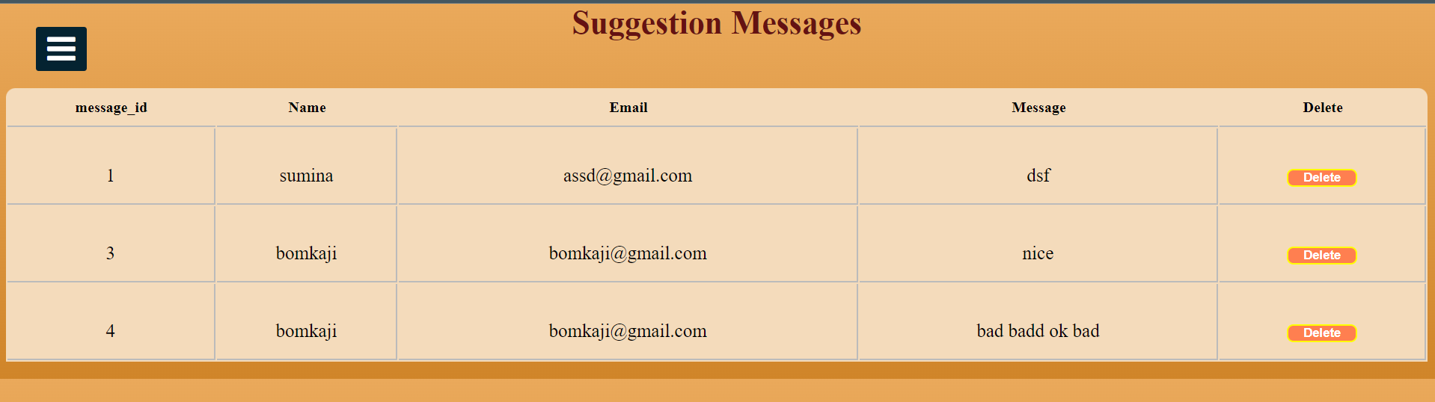

Fig 5.1.9 Admin panel page

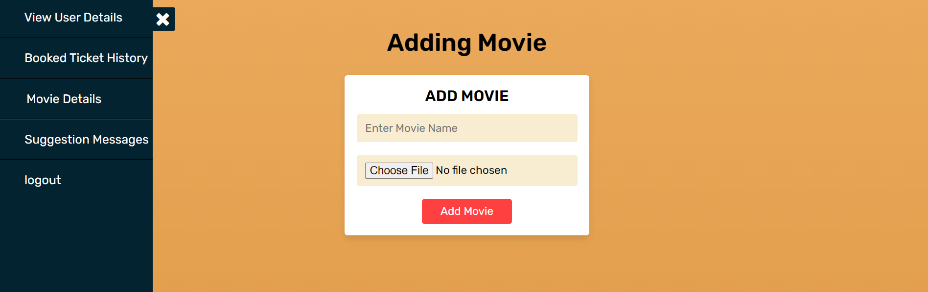

Fig 5.1.10 Admin Adding Movie page

## 5.2 Conclusion

Anime Store System was created with the help of HTML, CSS, JavaScript, PHP and MySQL. I have tried my best to provided easy interface to user. In order to create a program, we used the concept of SESSION, GET method, POST method, styling concept and database concept to store data.

**REFERENCES**

[1] [Movie - Simple English Wikipedia, the free encyclopedia](https://simple.wikipedia.org/wiki/Movie) 10th June 2023

[2] Qfx cinema, <https://www.qfxcinemas.com/home>, 16th February 2023

[3] Omax, <http://www.omaxcinema.com.np/Home.aspx>, 16th February 2023